Retail Marketing Campaign Analytics
A retail company wants to analyze customer buying behavior and marketing campaign performance using Snowflake sample data.
The company has three teams:
1. Marketing Analysts
2. Finance Team
3. ETL Developers
Each team should use a separate warehouse. The company also wants to improve query performance using:
1. Warehouse scaling
2. Query result cache
3. Cluster key on customer sales date
Use Snowflake sample data from:
SNOWFLAKE_SAMPLE_DATA.TPCDS_SF10TCL.STORE_SALES
SNOWFLAKE_SAMPLE_DATA.TPCDS_SF10TCL.CUSTOMER
SNOWFLAKE_SAMPLE_DATA.TPCDS_SF10TCL.DATE_DIM
SNOWFLAKE_SAMPLE_DATA.TPCDS_SF10TCL.ITEM
________________________________________
Questions
Part 1: Warehouse Setup
Create three warehouses:
1. MARKETING_WH for marketing analysts
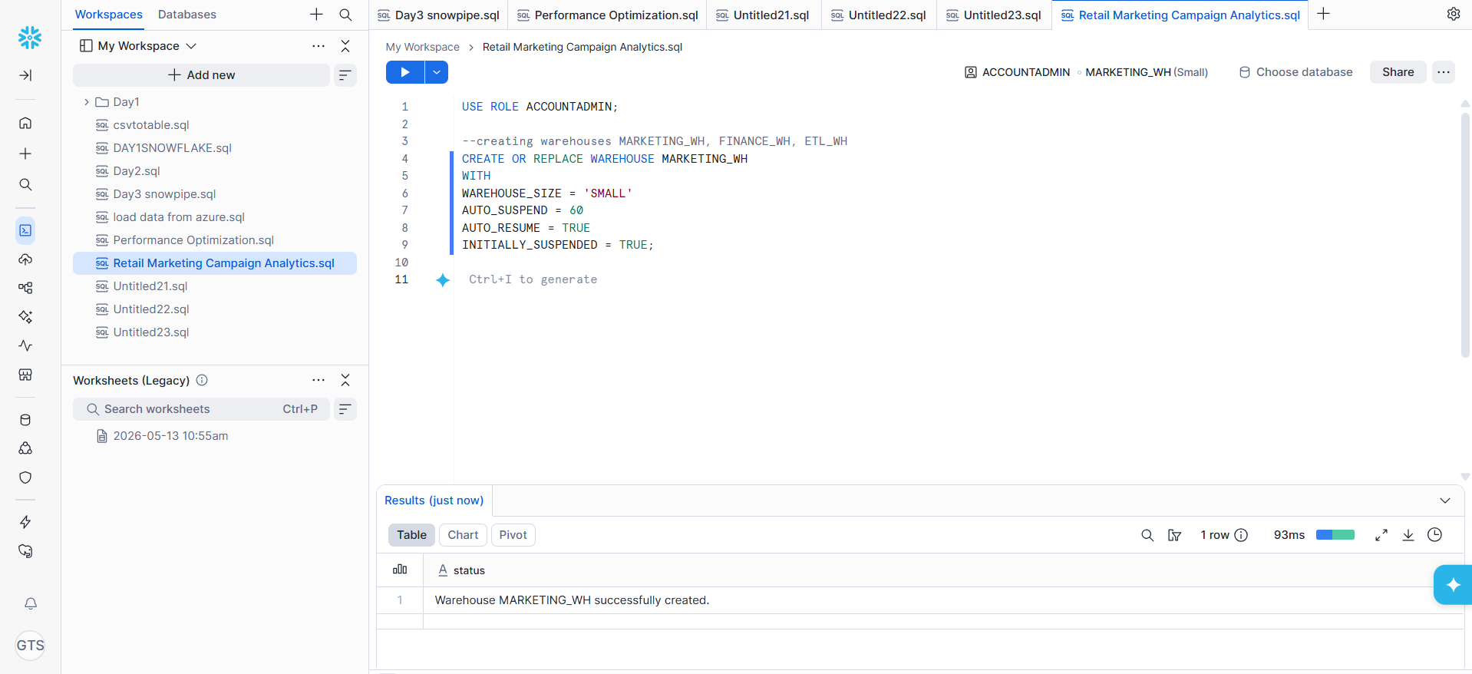
2. FINANCE_WH for finance team
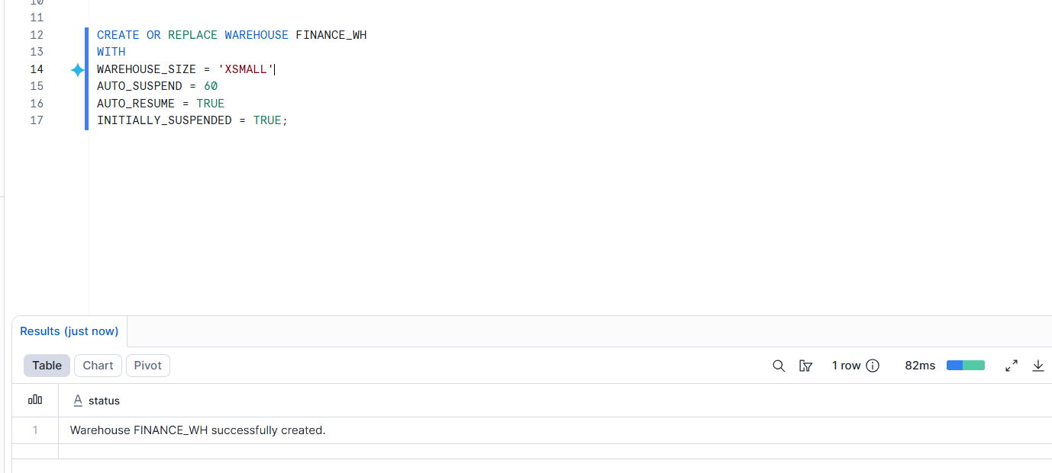
3. ETL_WH for ETL developers
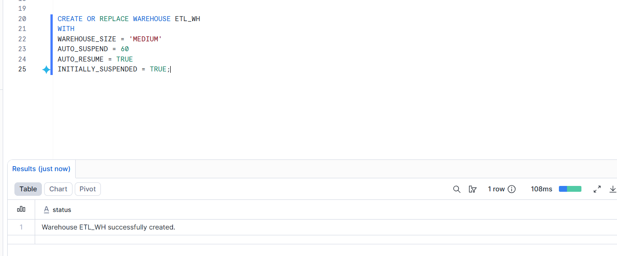
Use different warehouse sizes based on workload.

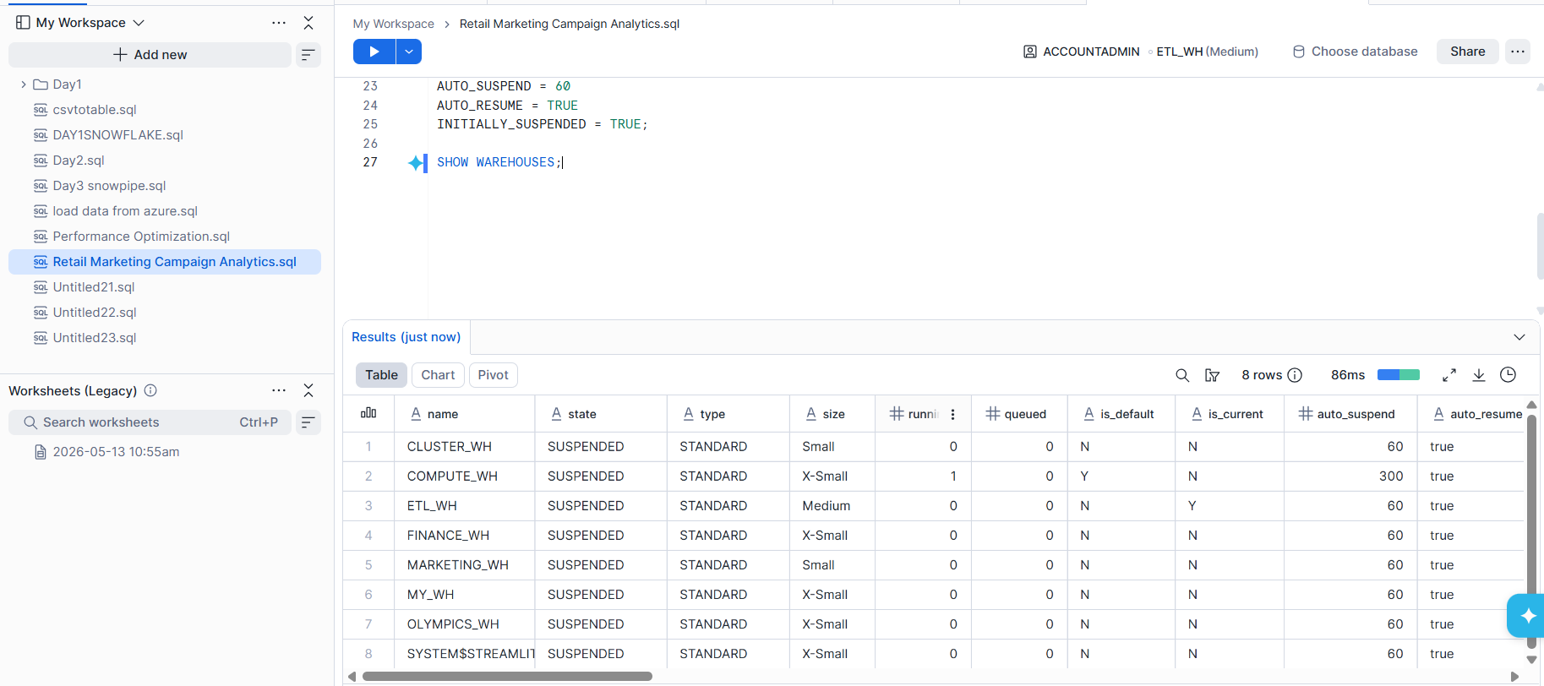
________________________________________
Part 2: Role Setup
Create three roles:
1. MARKETING_ANALYST
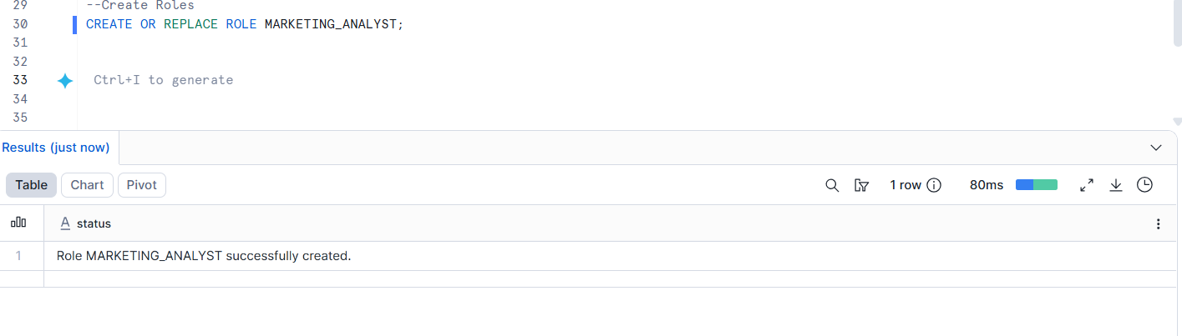
2. FINANCE_USER
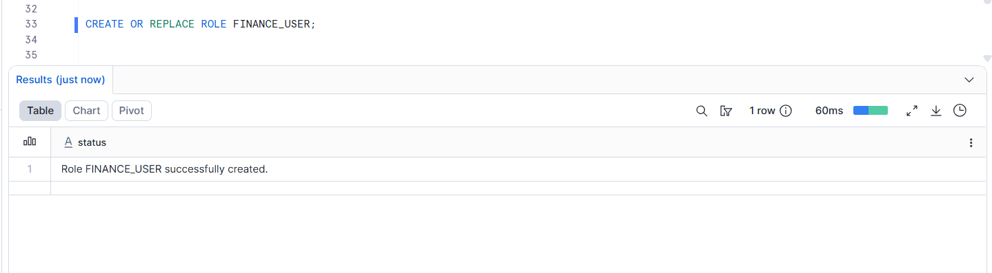
3. ETL_DEVELOPER
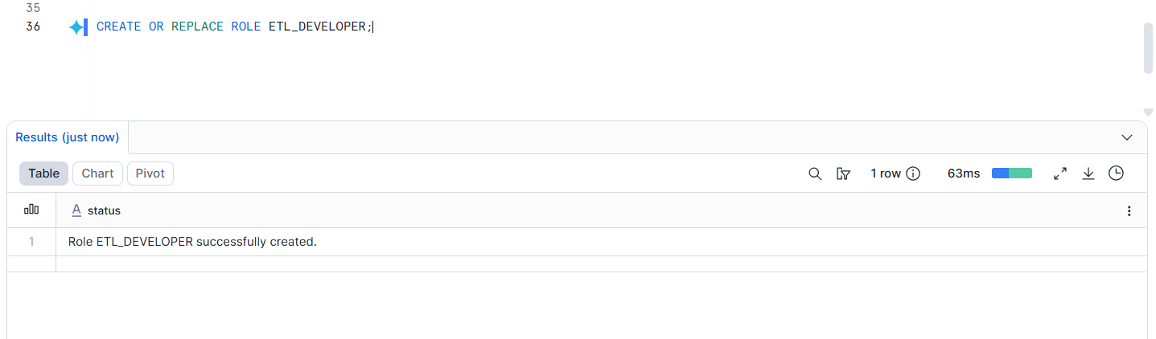
Grant each role access only to its assigned warehouse.
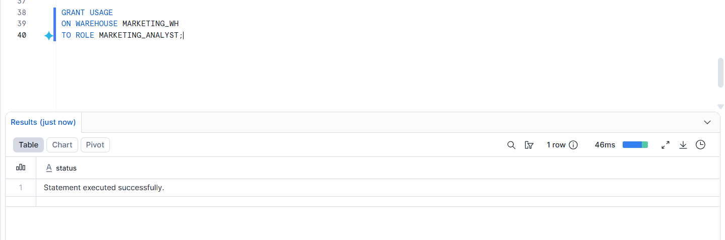
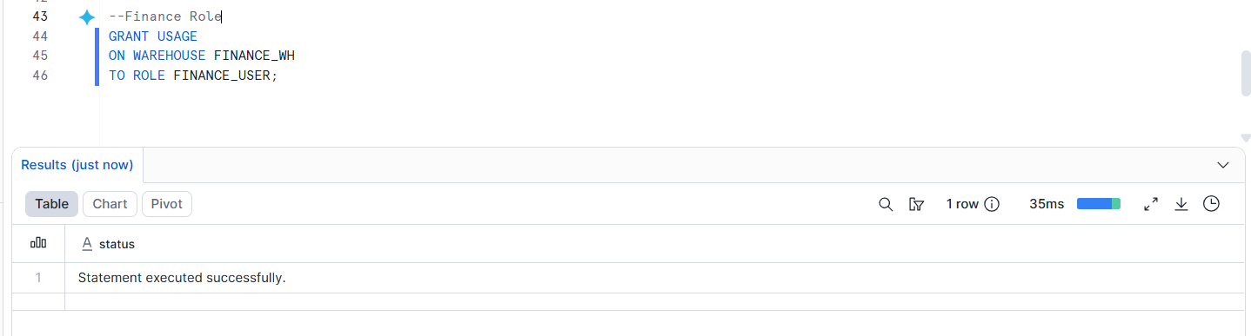
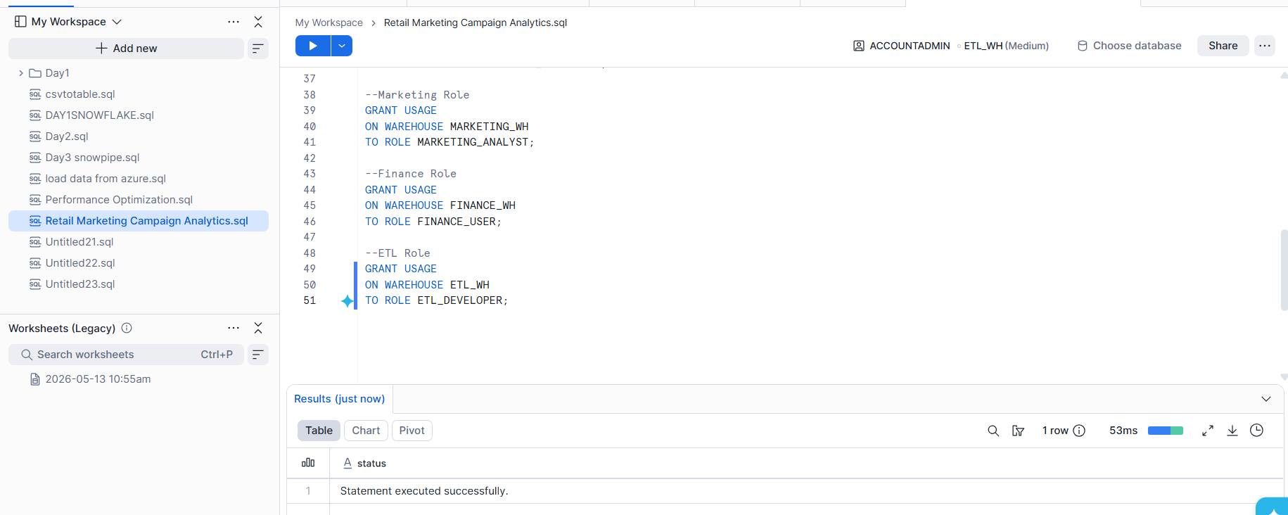
________________________________________
Part 3: User Setup
Create users:
1. MKT_USER1
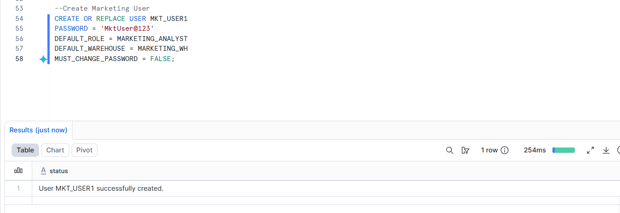
2. FIN_USER1
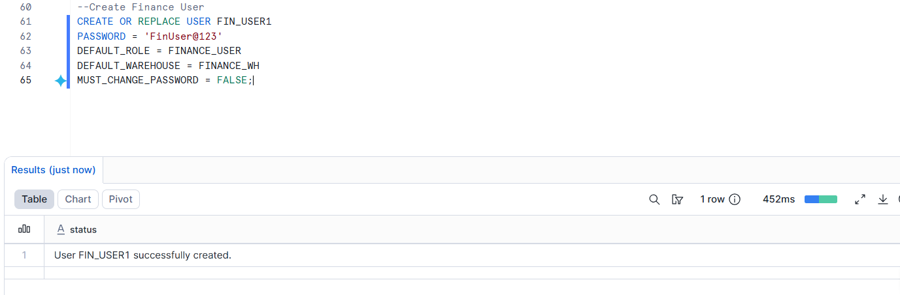
3. ETL_USER1
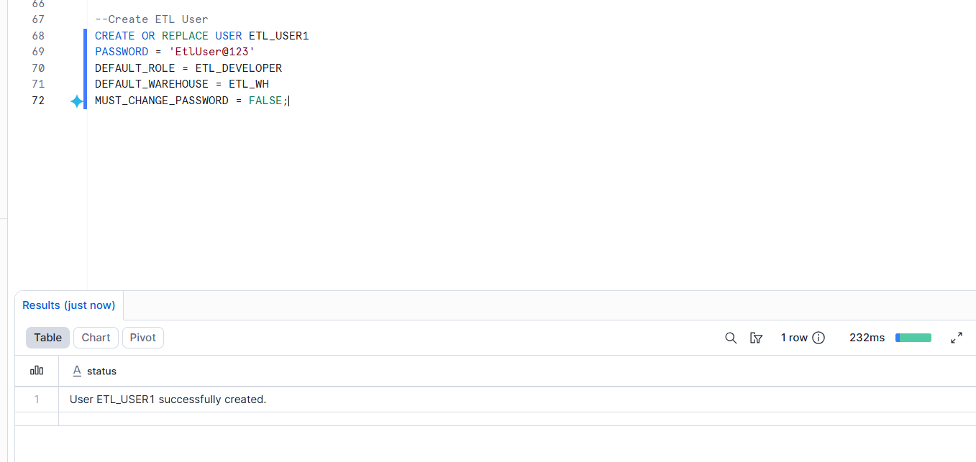

Set default role and default warehouse for each user.
________________________________________
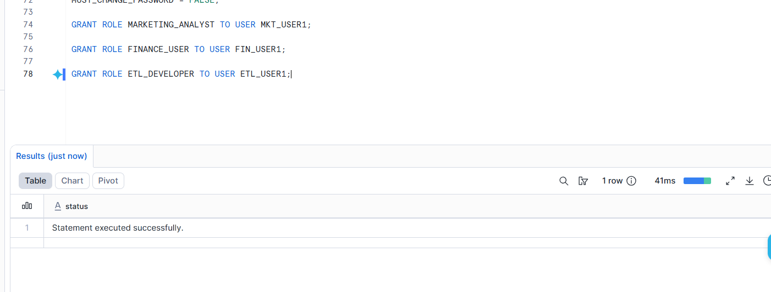
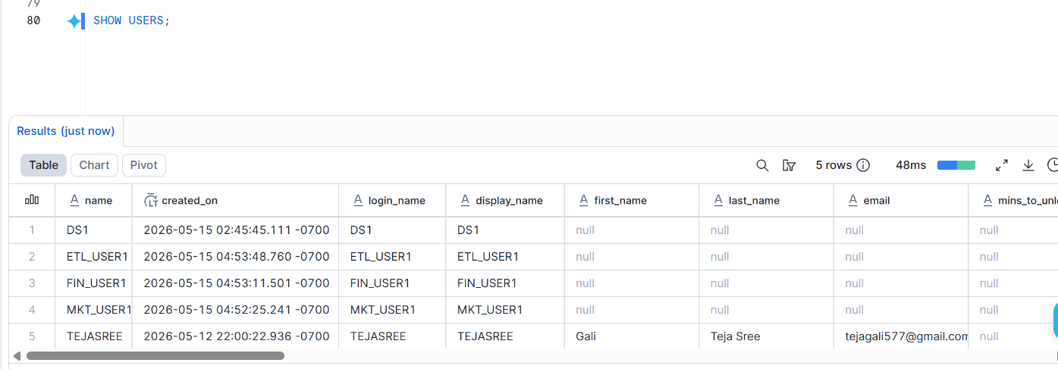
Part 4: Create Performance Demo Database
Create a database called:
RETAIL_MARKETING_DB
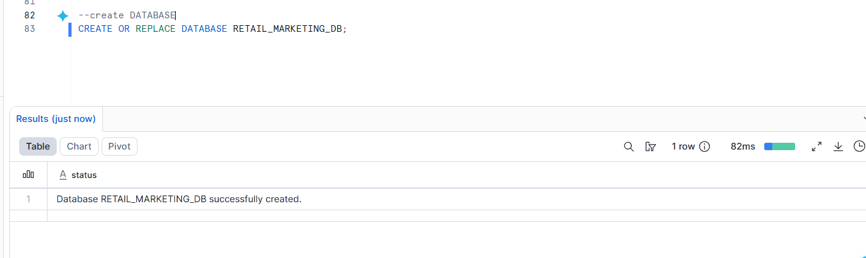
Create a table called:
CAMPAIGN_SALES
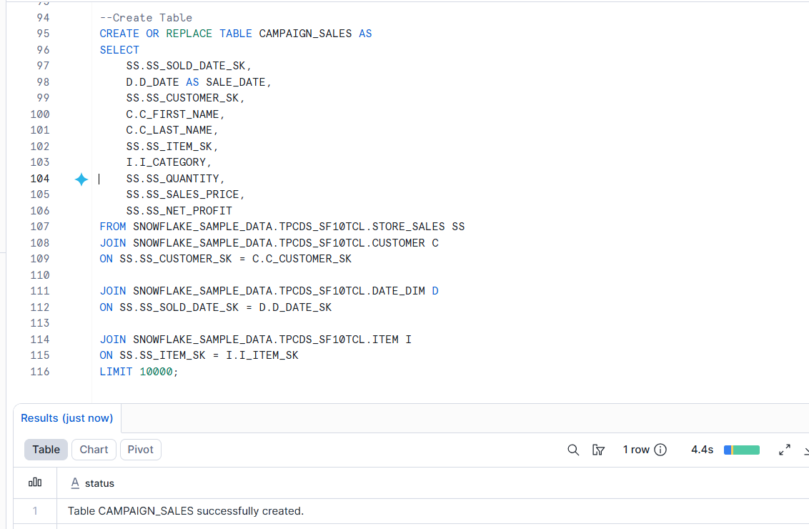
using Snowflake sample tables.
________________________________________
Part 5: Grant Permissions
Grant proper database, schema, and table permissions to each role.

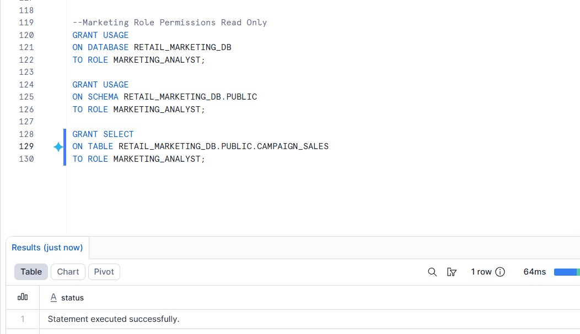
Marketing and Finance can only read data.

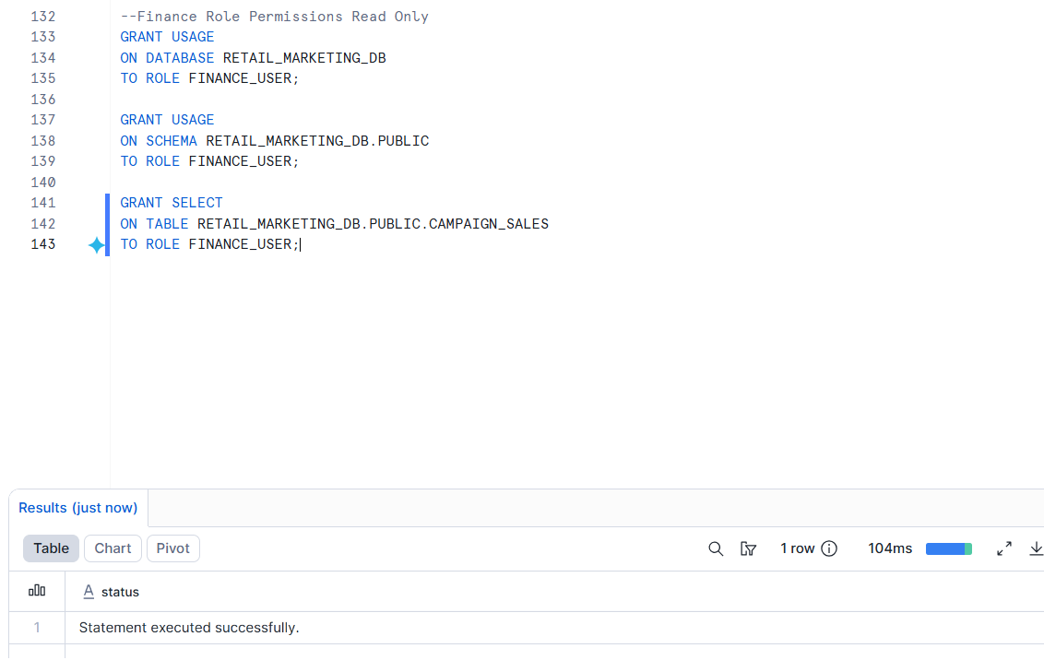

ETL Developer can create and modify tables.
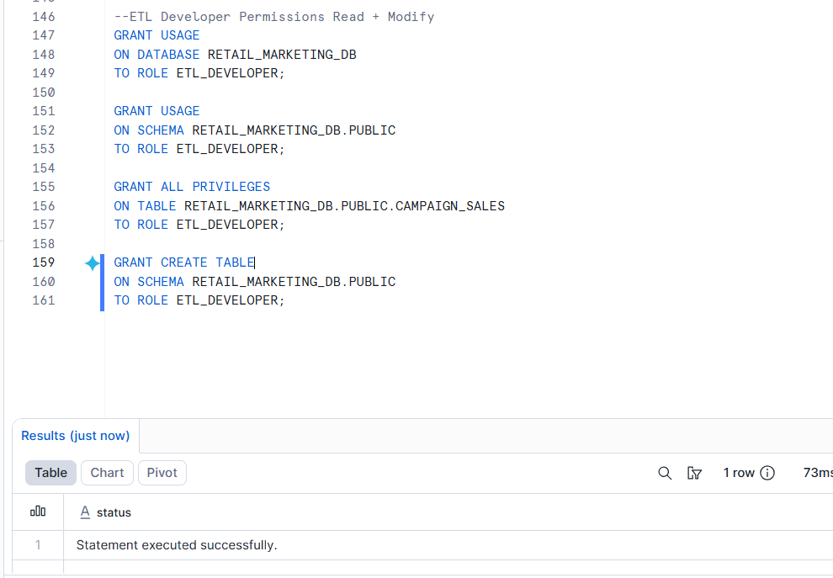
________________________________________
Part 6: Performance Testing
Run a sales analysis query using XSMALL warehouse.
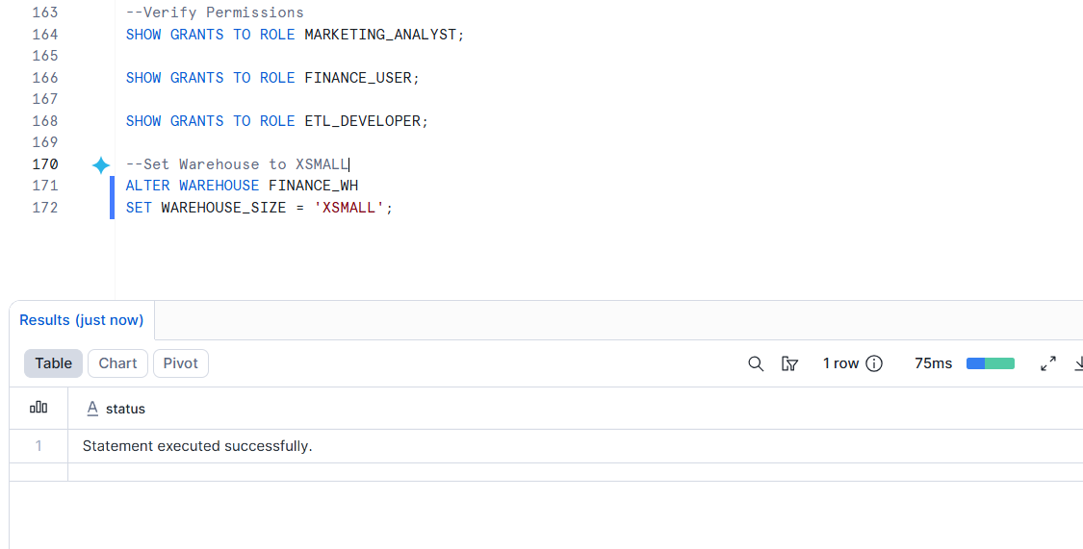
Observe Performance
Check:
- execution time
- query profile
- bytes scanned
Go to:
- Query History
- Query Profile

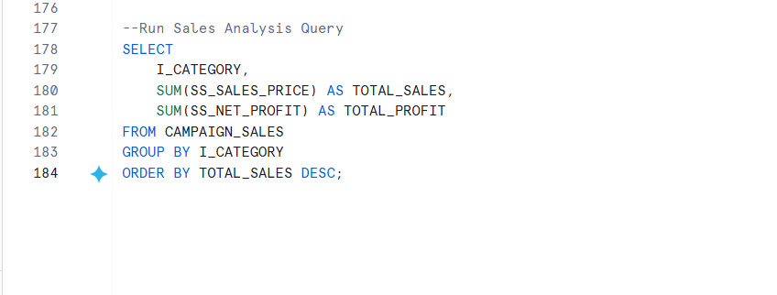
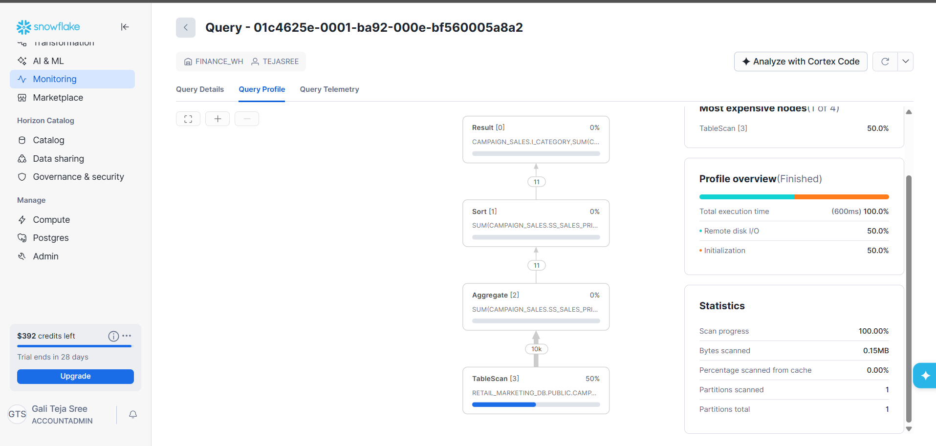
Then scale up the warehouse to SMALL.
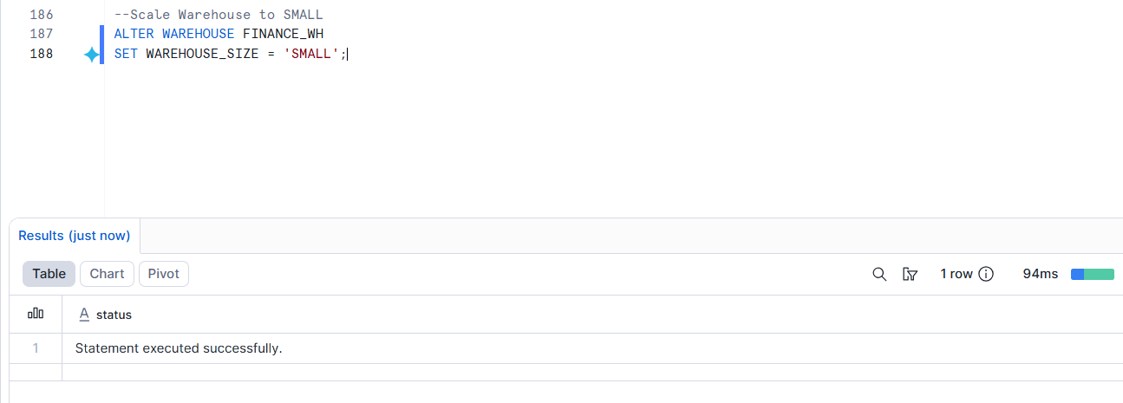

Compare performance.
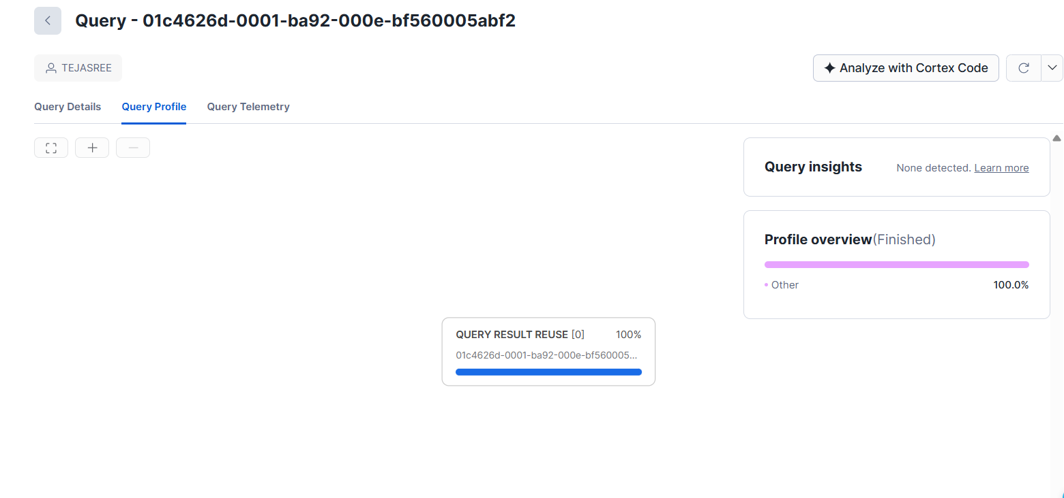
Then scale it down again.
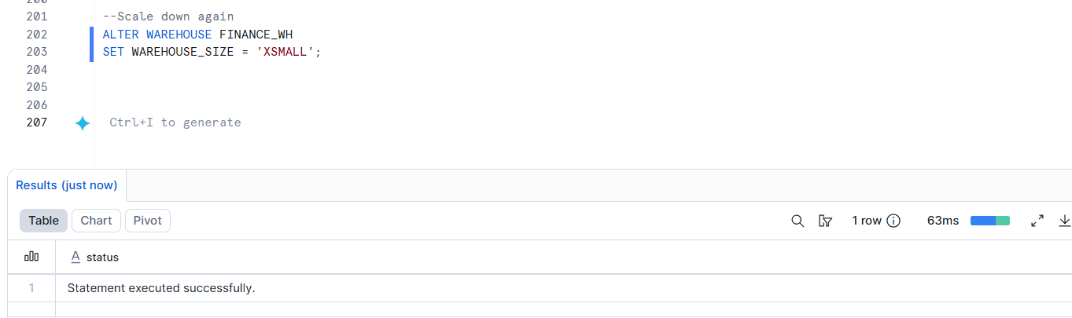
________________________________________
Part 7: Cache Testing
Run the same query twice.
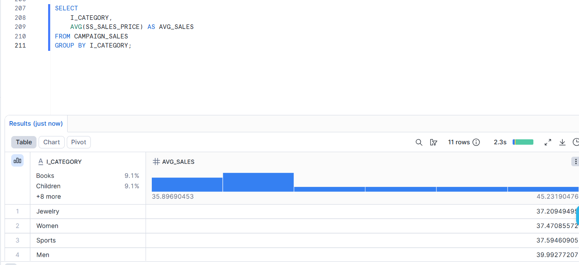
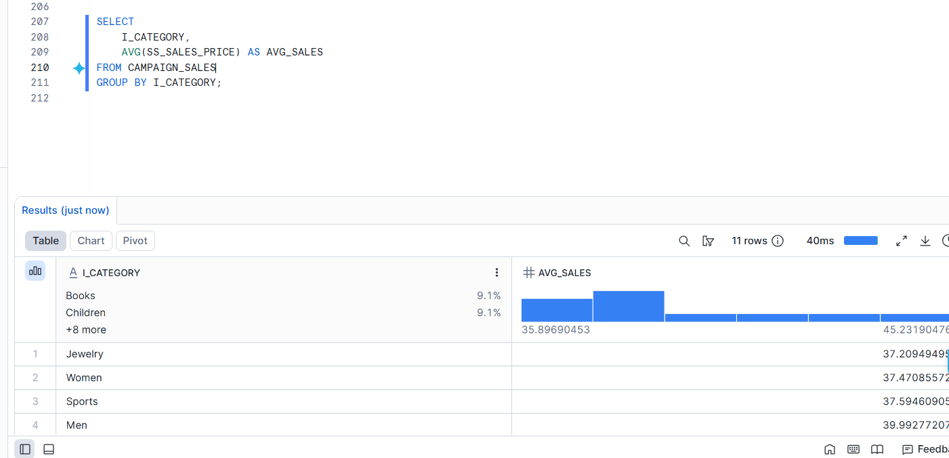

Observe why the second query is faster.
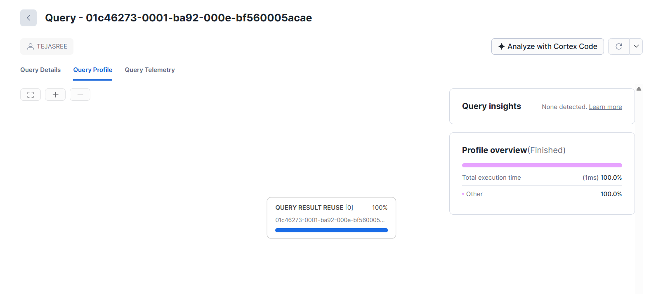
Snowflake stores results in Result Cache.
If:
- same query
- same data
- no table changes
then Snowflake returns cached result instantly.

________________________________________
Part 8: Cluster Key Testing
Run a date-filter query before clustering.
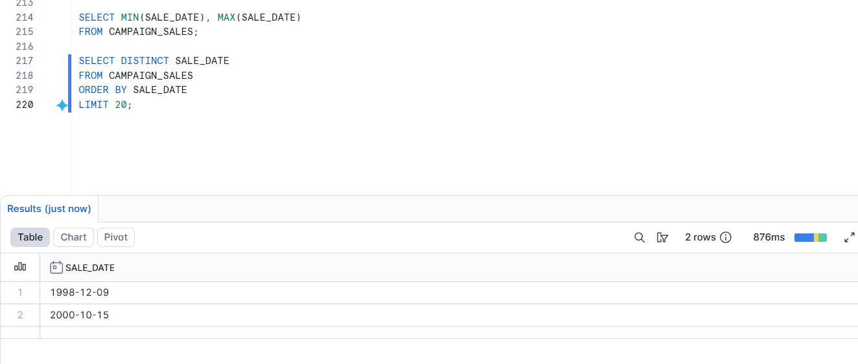
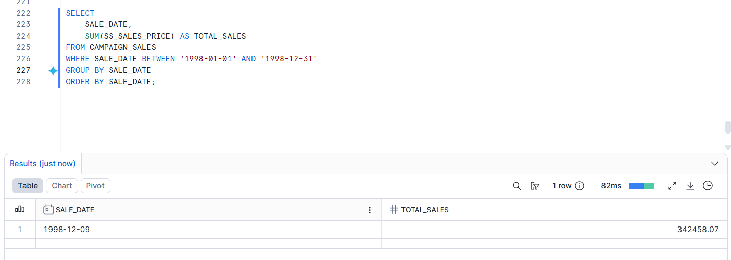

Add cluster key on SALE_DATE.
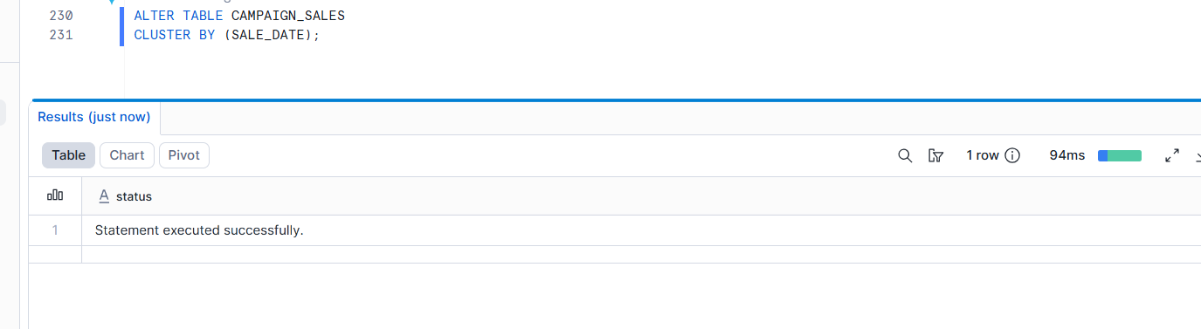
Run the same query again.
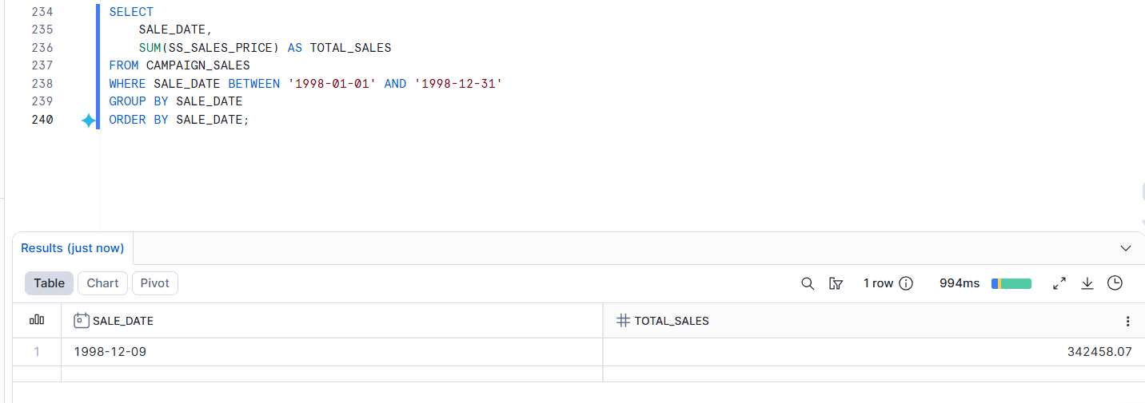
Compare performance.
